Research Report - DRAFT

**Buffaloberry: Implications of logging, site and climatic factors on plant cover and berry abundance in British Columbia**

Julia Chandler, Evelyn Hamilton, Garth Mowat, Cora Skaien and others TBD

April 24, 2025

# 1. INTRODUCTION

There is much interest in increasing habitat suitability for grizzly bears (*Ursus arctos horribilis*), a species of special concern (COSEWIC 2012). *Shepherdia canadensis* (known locally as buffaloberry or soapberry) berries (Figure 1) are often selected for by grizzly bears in summer or early fall (Nielsen et al. 2004; McClelland et al. 2020, Clarke 2022) when bears require considerable calories prior to hibernation (Nelson et al. 1983). Buffaloberry is widespread in BC and described in detail in the Biogeoclimatic Ecosystems Classification (BEC) Regional Field Guides ([BECweb](https://www.for.gov.bc.ca/hre/becweb/resources/classificationreports/index.html) 2025). Lamb 2019, Burton et al. (2000), Beaudry et al. (2001), Burton (2006), Proctor et al. (2023) and McLellan (2023) provide information relevant to management.

Buffaloberry is an upright, shade-tolerant/intolerant, early to mid seral, drought and frost tolerant, deciduous, N-fixing shrub that grows to 1-4 m in height and has small red berries that grow in groups. It occurs predominantly in boreal and cool temperate climates on very dry to moderately dry, often on sandy, rocky, or gravelly nutrient poor soils (Lamb 2015, Klinkenberg 2020). In BC it is typically found in interior valleys on open mesic to dry sites. The modal BEC zone is the IDF Zone (Klinkenberg 2020).

This study was done to determine how climatic conditions, site factors and forestry practices influence buffaloberry plant cover and berry production and provide guidelines regarding how to maintain and enhance berry production in grizzly bear habitat.

Figure 1. Buffaloberry (*Shepherdia canadensis*) berries and leaves. Photo credit: Garth Mowat.

# 2. METHODS

Sampling occurred in locations with bear foods and did not include sites where bear foods (i.e. berries) were not expected to be found. The study does not represent a comprehensive provincial assessment as sampling intensity varied by BEC subzone variants and many variants were not sampled.

Plant cover (%), berry abundance (#/100m2) and associated predictor variables were collected from 864 sites across the province in 2016, 2017, 2018 and 2022 (Figure 2). The predictor variables included site variables[1] (canopy cover, elevation, latitude, longitude, slope and aspect), site history (unlogged or various silviculture systems including clearcut and clearcut with reserves) and modelled climate data for the current year as well as the two preceding years, referred to as the “previous year” or “two years prior”. These data were downloaded from the ClimateBC database (Wang et al. 2016, [ClimateBC.ca](https://climatebc.ca/)).

Figure 2. Distribution of buffaloberry (*Shepherdia canadensis*) across North America[2] (A); and study sample sites located in six biogeoclimatic zones across British Columbia, Canada (B). Elevation is represented in gray with areas of higher elevations showing darker colours.

2B.

2A.

2.1. Field sampling

Buffaloberry plant cover (%) and berry abundance (#/100m2) and associated site data[3] and site history (i.e. logged or not) were collected in the field using standard ecological methods. Site aspect (i.e. azimuth) values were converted to ‘folded aspect’[4]

Buffaloberry plant cover and berry abundance data were collected within 0.82 m diameter hoops (0.53 m2) set within larger 100m2 plots. All plants within the 100m2 plot had a 0.82 m diameter hoop placed around it to determine plant cover and berry abundance. Each hoop represented ~0.5% of the 100 m2 plot, allowing for extrapolation of berry abundance to the 100 m2 plot level, based on species cover within the 100 m2 plot. If the plant did not fill the entire hoop, then the number of berries counted was divided by the proportion of the hoop for which the plant covered (e.g., if 200 berries were counted and the plant covered 60% of the hoop area, then there would be 200/0.60 = 333 berries/0.53 m2). Sometimes with buffaloberry, when the plant was particularly productive, the top three representative branches were counted and then extrapolated to the total number of branches present within the hoop.

We constructed models using a recursive partitioning method with the R rpart package (Therneau and Atkinson 2023) with default settings (*p* < 0.01). Six key zones were identified (i.e. those in which berry-bearing buffaloberry plants occurred in at least 25 sites, the BWBS, ESSF, ICH, IDF, MS and SBS and not the SBPS, MH and SWB zones). One model was generated for each response variable (buffaloberry plant cover and berry abundance) incorporating all predictor variables (*n=*744) for each of the six key zones (Tables 1 and 2) See the Addendum for details on the variables included in the models.

We plotted buffaloberry cover and berry abundance vs canopy cover and berry abundance vs buffaloberry cover (Appendix 1). We also plotted buffaloberry plant cover, berry abundance and tree canopy cover in logged and unlogged sites by variant (Appendix 2).

### 2.2. Statistical analysis

Decision trees representing each model were generated using the rpart.plot package (Milborrow, 2024). The rpart analysis identifies the predictor variables that best explain the response (i.e. buffaloberry cover or berry abundance). The decision tree first splits the tree into two “branches”. The variable associated with the first split in the tree is the predictor variable that is best correlated with the variation in the response variable. Each binary split maximizes the between-branch sums of squares (or equivalently minimizes the pooled within-branch sums of squares) of the dependent variable. The optimal split is determined for all predictor variables and the one that yields the best separation becomes the first split. The process then repeats for each subsequent tree branch, calculating further subsets of the data until no appreciable improvement in sums of squares can be made.

### 2.3. Location of sites

#### 2.3.1 Location by BEC units

Most sites were in the SBS zone (i.e.107/353 (30.7%), with lower numbers in the MS (65, 18%), BWBS (60,17.2%), ICH (52,14.9%), ESSF (32,9.1%) and IDF (23, 6.5%) zones and very few sites in the MH (3), SBPS (1), and SWB (6) zones (Tables 1 and 2).

Berry-bearing buffaloberry plants can be found in a wide range of BEC subzones, from the warm dry IDF to the cold BWBS Zone (Figure 2). In the SBS zone, sites were found in the moist cool subzones and in the warm and cool subzones in the MS zone, in moist subzones in the ICH and in very dry and dry, cool and cold subzones in the IDF. All sites in the BWBS were in the moist cool subzone (i.e. BWBSmk).

#### 2.3.2 Location with respect to logging history

The majority (68% - 240/353) of the sites were not logged. Virtually all of the BWBS sites (i.e. 98%), 70% of IDF, 67% of SBS, 62% of ESSF, 55% of MS, and 50% of the ICH Zone sites were in areas that were not identified as having been logged (Tables 1 and 2).

# 3. RESULTS

### 3.1 All Zones

Buffaloberry berry abundance was on average greater than 2400 berries/100m2 where species cover was above 15% although this could be higher in sites that were logged despite a species cover of only 5-10% (Figure 3A). Buffaloberry berry abundance decreased with increasing canopy cover above 20% (Figure 3B). In logged sites, very little or no berries were found where canopy cover was greater than 30%. In unlogged sites some berries were found at canopy cover levels up to 70-80%. Buffaloberry cover averaged near or below 5%, regardless of canopy cover (Figure 4) while canopy cover did not exceed 30% on logged sites (Figures 3B and 4).

Including only the six zones with more than six sites, buffaloberry cover and berry abundance were overall moderately correlated (r=0.56) (Figures 5 and 6). Highest correlations were found between the response variables in unlogged sites (r=0.65 in the ESSF and r=0.85 in the IDF) and lowest correlations were in logged sites (r=0.15 in the ESSF and r=0.24 in the SBS).

Where logging occurred (sites with a more open canopy), buffaloberry plant cover was higher in warmer and drier zones (the MS and IDF), but lower in the cooler moister sites (the ICH and SBS); and seemed no different from unlogged sites in the ESSF (Figure 5). Berry abundance was highest in the IDF and MS and higher in logged vs unlogged sites except in SBS (Figure 6). Average canopy cover was consistently higher (>=29%) in unlogged sites compared to logged sites (<=11%) across all zones (Figure 7).

### 3.2 BWBS Zone

In the BWBS 98% of the sites were not logged and all sites were in the BWBSmk subzone. Berry abundance increased with buffaloberry cover (r=0.56) and slope (r=0.45) in unlogged sites, no significant correlations were found to other predictor variables (Appendix 3.1A). Berry abundance increased with greater precipitation in June of the current year, previous year and two years prior (r=0.3 to 0.33) and was weakly negatively correlated with spring and autumn temperature (r=-0.27 to -0.32) of the current and previous year (i.e. more berries where there had been cooler and moister spring and cooler fall weather). Berry abundance was greater where canopy cover was <38% (mean # berries/100m2=2224, *n*=32) vs where it was >38% (mean=772, *n*=28) (Appendix 3.2A). In more open canopy sites, there were more berries where there had been fewer degree days below freezing in the current spring (i.e. warmer spring conditions) (mean=3224, *n*=17) vs where conditions had been colder (mean=1091, *n*=15) (i.e. more berries in open sites where there had been more days with above freezing temperatures in the current spring). Overall better conditions were found in sites than had experienced cooler weather but fewer days below freezing in the current spring.

### 3.3 ESSF Zone

Of the 32 sites in the ESSF zone 62% were not logged. Sites occurred in the ESSFxv (3)[5], xc (5), dk1 (4), dk2 (6), dv2 (6), mh (2) and mm (6) subzone variants. Buffaloberry cover was moderately positively correlated with indicators of moist cool winter (Appendix 3.1B) and moist spring climatic conditions (r=0.50 to 0.59) and weakly positively correlated with higher summer humidity (r=0.40). Berry abundance was moderately positively correlated with buffaloberry plant cover (r=0.52) and with May climatic moisture index the previous year (r=0.46)and relative humidity 2 years prior (r=0.58). Berry abundance was also negatively correlated with indicators of higher maximum winter temperatures in January (Tmax01) (r=-0.41) and February (Tmax02) (r=-0.49) (Appendix 3.2B) and May climatic moisture deficit of the previous year (CMI04_1) (r=-0.48). Overall best locations were where there had been moister spring and summer and cooler winter conditions.

### 3.4 ICH Zone

In the ICH 50% of the 52 sites were logged. Sites were found in the ICH dm (1), dw1 (3), mk4 (12), mk5 (1), mw1 (20), and mw5 (1) subzone variants. Buffaloberry cover was slightly lower in logged sites (r=-0.28) and weakly positively correlated with average and minimum winter temperatures (r=0.28 to 0.31) and weakly negatively correlated with degree days below zero in the winter (r=-0.31) indicating that cover was higher where conditions were not as cold. Plant cover and berry abundance were. weakly negatively correlated with slope in unlogged sites (r=~-0.30; Appendix 3.1C) but in logged sites this relationship was not found (cover r=-0.16 and abundance r=0.06) (Table 3). Berry abundance was weakly positively correlated with buffaloberry cover (r=0.39), decreased with increasing canopy cover (r=-0.45) and was somewhat higher in logged sites (r=0.34). Abundance was higher in sites that had experienced moister weather conditions (r=0.3 to 0.4); greater where there had been more snow the previous January (PAS01>62 mm) (mean=8707, *n*=8) vs where PAS01<62 mm (mean=1398, *n*=44) (Appendix 3.2C). Overall better conditions were found in open logged sites that had experienced warmer moister winter conditions.

### 3.5 IDF Zone

In the IDF 70% (16/23) sites had not been logged. Sites were in the IDF dc (17) dk2 (3) and xc (3) subzone variants. Buffaloberry cover was weakly positively correlated with canopy cover in sites that had not been logged (r=0.32) and that had higher precipitation in August of the current year (r=0.29). Cover was somewhat greater where the Hogg’s climatic moisture index in December 2 years prior (CMI11_2) was >7.6 mm (i.e. where winter conditions had been more humid) (mean=14%, *n*=9) vs where CMI11_2 was <7.6 mm (mean=5.8%, *n*=14) Appendix 3.1D). Cover was greater where there had been moister weather conditions. Berry abundance was very strongly positively correlated with buffaloberry plant cover in sites that had not been logged (r=0.85) and moderately positively correlated logged sites (r=0.49). Abundance increased with elevation (r=0.7) in logged sites. Berry abundance was greater (mean=6342, *n*=12 where maximum temperature in March of the current year (Tmax03) indicated cooler spring temperatures (i.e. was <3.9oC) vs where Tmax03 was >3.9oC) (mean=2224, *n*=11; Appendix 3.2D). Overall better conditions were found where the weather had been moister and cooler and at higher elevations.

### 3.6 MS Zone

In the MS zone 55% (36/65) of the sites were not logged. Sites were in the MSdc1(8), dk (17), dm2 (1), dw (35) and xv (6) subzone variants. Berry abundance was moderately positively correlated with buffaloberry plant cover (r=0.41) and greater in logged sites (r=0.32). There were more berries where the folded aspect[6] was >154°, (i.e. on warmer SSE- to SSW- facing sites) (mean=7940, *n*=22) compared with cooler aspect sites (mean=3345, *n*=45) (Appendix 3.2E). Overall better conditions were found on logged sites and on warmer aspects.

### 3.7 SBS Zone

In the SBS 67% of the sites were not logged. Sites are in the SBSdw3 (19), mk1 (66), wk2 (7) and wk3 (5) subzone variants. The majority of sites (66/107) were in the SBSmk1 subzone variant. Buffaloberry cover (r=-0.4) and berry abundance (r=-0.21) were lower in logged sites. Berry abundance was moderately positively correlated with buffaloberry cover in sites that were not logged (r=0.48) and weakly positively correlated in sites that were logged (r=0.24). In warmer sites (DD5>=990), logged sites had a lower average cover (mean=2.3, *n*=33) compared to unlogged sites (mean=5.4, *n*=63) (Appendix 3.1F). Berry abundance was greater (mean=4664, *n*=18) where the minimum temperature in April of the previous year was higher (i.e. >-0.65oC) vs where it was lower (i.e.<-0.65°C) (mean=1686, *n*=89) (Appendix 3.2F). In the sites with cooler April temperatures berry abundance was greater where the November climatic moisture index the previous year (CMI11_1) was < 0.4 (mean=3237, *n*=31) i.e. drier conditions vs where CMI11_1 was >0.4; mean=857, *n*=58). Overall higher buffaloberry cover and berry abundance were found in unlogged sites.

### 3.8 Summary

Sites with low canopy cover generally provided the best environments for berry production; logged areas usually had lower canopy cover than unlogged sites. The best sites for berry production were found in the IDF followed by the MS zone. In the IDF the best sites had low canopy cover and were at higher elevations and where there had been moister cooler weather conditions. In other zones the best sites were in logged areas – in the SBS in sites where there had been warmer spring conditions, in the ICH where there had been warmer moister winter conditions and in the MS on warmer aspects. In the ESSF best locations were where there had been moister spring and summer and cooler winter conditions. In the BWBS best conditions were found in sites than had experienced cooler weather but fewer days below freezing in the current spring.

# 4. DISCUSSION

### 4.1 Considerations

Buffaloberry cover was relatively low in most sampled sites, and this limits the potential range of berry abundance values making determination of the influence of predictor variables more difficult.

The study does not represent a comprehensive provincial assessment as sampling intensity varied by BEC subzone variants and many variants were not sampled. Sampling was restricted to locations with bear foods and did not include sites where bear foods were not expected to be found.

The weather in the years in which sampling was done (i.e. 2016 to 2020) and preceding years (e.g. 2015) – found to be influential – was significantly different from normal conditions. In 2015 and 2016 weather was warmer province wide, 2018 was drier and warmer in the north and 2020 was generally wetter and cooler (See the [BC Climate Anomaly](https://bcgov-env.shinyapps.io/bc_climate_anomaly) app). Year to year variation in berry abundance as a consequence of weather conditions limits interpretations of the influence of other predictor variables. Sampling in some zones was restricted to one of these years (i.e. SBS only in 2016, BWBS only in 2017, IDF only in 2020). Influences of pollinator availability and fruit herbivory and history (e.g. time and date of logging) could not be accounted for.

### 4.2 Relationship between buffaloberry cover and berry abundance

The overall correlation between buffaloberry cover and berry abundance was positive and significant as expected (Figure 3A). However, sites that had the greatest plant cover didn’t necessarily provide the greatest berry abundance. Buffaloberry cover was usually best correlated to site factors like canopy cover, logging, aspect and slope whereas berry abundance was best correlated with climatic conditions. Because berry abundance varies so much year to year, using buffaloberry cover as a metric to identify best sites to manage for abundance is reasonable. However, there could be significant differences in berry abundance – with the same level of plant cover – in different years. Furthermore, the correlation between berry abundance and plant cover is weaker in logged sites versus unlogged sites in some zones (ESSF not logged r=0.65/logged r=0.15; IDF not logged r=0.85/logged r=0.49; SBS not logged r=0.47/logged r=0.24).

Site conditions (Lamb 2015), climatic conditions in current and past years (McLellan 2023, Krebs et al. 2009), and availability of pollinators (Lin et al. 2015) affect berry production. Lin et al. (2015) found parent plant density affected pollinator behaviour and hence berry abundance. Denny et al (2018) reported that buffaloberry fruit density was a function of environmental and demographic factors such as local canopy cover (Hamer 1996, Nielsen et al. 2004b). These factors may explain in part the variation in correlations we found between buffaloberry cover and berry abundance.

### 4.3 Influence of climatic conditions on buffaloberry plant cover and berry abundance

Suitable conditions for berry production existed across a wide range of BEC zones and ecological conditions. Mean cover was highest in the IDF – the warmest and driest zone; colder wetter zones (e.g. BWBS, ICH) appear less favourable (See the [UBC subzone variant climate analysis](https://cfcg.forestry.ubc.ca/resources/cataloguing-in-situ-genetic-resources/subzonevariant-climate-analysis/)). The IDF, a warm, dry zone, is the modal zone for buffaloberry (Klinkenberg 2023) indicating that it is well adapted to relatively dry, warm environments. In the SBS sampled sites were located across a wide spectrum of climatic conditions; cover was higher where conditions were cooler whereas berry abundance was higher where there had been warmer spring conditions (i.e. circa above 0 0C) and drier November conditions.

In the ICH on logged sites and in the MS, which is a fairly dry and cool zone, warmer aspects with moister environments appear to provide better conditions for buffaloberry berry abundance. Climatic conditions in parts of the MS are similar to the IDF although the MS is generally cooler and moister. In the cold climate of the BWBS the more open canopy-inclined sites may offer warmer conditions with greater light availability and deeper snowpacks. Deeper snowpack may provide greater frost protection and conditions favourable to buffaloberry berry production as the plant is best adapted to dry, warm environments (Klinkenberg 2020).

Our results are consistent with others in recognizing the importance of climatic conditions in the current and preceding year. Buffaloberry is adapted to a drier moderate continental climate (Klinkenberg 2020) and characteristic of montane spruce and pine forests (Wilkinson 1990) and temperate and boreal forests (LaRoi and Hnatiuk 1980). In the Kootenays, Lamb (2015) found buffaloberry was most likely to occur in areas where the mean annual precipitation and canopy cover were the lowest – i.e. in drier regions. In the Yukon berry production was strongly positively correlated with previous July rainfall (Krebs et al. 2009) indicating berry production is sensitive to climatic conditions in previous summers. Having sufficient snowfall and warm enough winter temperatures to avoid freezing damage and sufficient summer rain, especially in drier regions, appears important.

### 4.4 Influence of canopy cover and disturbance history on buffaloberry cover and berry abundance

#### 4.4.1 Influence of canopy cover

Sites that had not been logged had at least 20% more canopy cover than logged sites in all zones. Because of the considerable reduction in canopy cover from logging, it is difficult to separate the implications of canopy cover from those associated with logging. However, our results are consistent with others who observed that buffaloberry is well adapted to open canopy environments (McLellan 2018, Bateman and Nielson 2020, Nielson et al. 2004**,** Clarke (2022) and that open sites support better berry production (Burton 2006,1998; Bateman and Nielson 2020, Burton et al. Clarke 2022).

#### 4.4.2 Influence of logging

Species cover was highest in the IDF followed by SBS, and higher in unlogged sites in SBS and ICH (the BWBS didn’t have more than one logged site). Berry abundance increased with buffaloberry cover - in logged and unlogged sites. Buffaloberry cover was on average higher in the unlogged sites vs logged sites in the SBS and ICH, but the inverse was found in the IDF and MS sites. On the other hand, berry abundance was generally higher on logged vs unlogged sites. This may reflect: (i) the fact that the plants in the logged areas had been negatively impacted by logging and have not yet reached high values; (ii) that the unlogged sites provide better conditions for the plant - which could be because they are in different zones, subzones, variants or site series or seral stages; and/or (iii) possibly the plants in logged sites had been negatively affected by recent weather events.

Buffaloberry was more likely to occur in harvested areas than in mature forest in Alberta foothills (Souliere et al. 2020); harvesting alone didn’t reduce the number of bushes but mechanical site preparation did (Nielson et al 2004). Fruit production was greater in disturbed stands vs mature forests and peaked in young (circa 20 year) stands compared with younger (5 year) and older age (60 year) classes (Souliere et al. 2020). In southeast BC scarification reduced the number of buffaloberry bushes in harvested stands but no difference in plant abundance was noted in logged sites vs mature forest (Knight 1999).

Our results are consistent with studies that found buffaloberry is fairly tolerant of timber harvesting insofar as it can resprout after disturbance and is adapted to open areas (Schryer et al. 2011). It can be negatively impacted by site preparation treatments like scarification that damage plants. (Knight 1999, Souliere et al. 2020, Nielson et al. 2004).

We did not examine implications of burning per se although it is likely that some logged areas had been burned. Burning was reported to be positive for buffaloberry plants and berry production (Hamer et al. 1983, Noble 1985, Walkup 1991). Likelihood of buffaloberry occurrence was positively correlated with time since fire in the BC mountain parks (McLellan 2018). Buffaloberry can be negatively impacted by severe fires that destroy root systems and impact it’s regrowth; it may take several years for plants to recover. However prescribed burning may be a useful tool to maintain open canopies and reduce competition from other species (Clarke 2022). There will likely be an initial decline in the species post fire and recovery can take up to 25 years in some sites (Zager et al. 1983).

### 4.5 Implications of site factors on buffaloberry cover and berry abundance.

We found buffaloberry berry cover was greater on steeper slopes in the BWBS and moderately to weakly negatively correlated with % slope in the ESSF and ICH. Productivity was weakly or very weakly positively correlated with % slope in most zones. This relationship varied on logged vs unlogged sites in these zones, notably in the ESSF where cover was strongly negatively correlated with % slope on unlogged sites and not correlated on logged sites.

Cover was greater on the warmer aspects in the ESSF and more strongly so on unlogged sites vs logged sites; cover was somewhat greater on logged vs unlogged MS sites. In the ESSF berry abundance was greater on the warmer aspects in unlogged sites but lower on logged sites. In the ICH berry abundance was greater on warmer aspects in logged sites. In the MS cover and berry abundance were greater on warmer aspects in logged sites. In cooler zones conditions provided on warmer aspects appear to be beneficial; this is consistent with buffaloberry being best adapted to warm dry conditions.

In the IDF cover and berry abundance increased with elevation in logged sites. Cover increased slightly with elevation in unlogged sites in the SBS while in the ICH cover decreased with elevation. Berry abundance increased with elevation on logged ESSF sites. The implications of elevation varied by zone and for cover vs berry abundance. In the dry warm IDF – logged higher elevation sites appeared to provide better conditions for both perhaps because conditions in lower elevation sites were too dry and warm particularly on exposed logged sites. Higher elevation sites in the ESSF were not necessarily above those in all sites in the ICH or SBS – since most ESSF sites sampled occurred in northern end of the study area where the ESSF begins at lower elevations. A number of factors including climatic conditions, the mix of other plant species vary by zone making differentiating the nature of the relationship with elevation per se complicated.

The probability of buffaloberry occurring increased somewhat as global radiation and % slope increased in the Kootenays; it was more likely to occur on mid slope valley bottom sites and where soils have a higher coarse fraction, less sand, and low organic C and higher pH (Lamb 2015). In the PNW Ferguson and Byrne (2016) found buffaloberry was most likely to occur on warm aspects. Nielson et al. (2004) reported the probability of occurrence decreased with elevation between 1050 to 1500 m and increased with an increase in slope aspect index - an indicator of site warmness. Buffaloberries ripen first on south-facing aspects and dry up sooner (Hamer 1996).

Our results are generally consistent with other studies that observed buffaloberry is adapted to warm, sloping sites and influenced by factors associated with elevation (Lamb 2015, Ferguson and Byrne 2016 and Nielson et al. 2004, Klinkenberg 2020 BC).

# 5. CONCLUSIONS

1. Although a number of factors influence berry production, berry abundance was positively correlated with buffaloberry cover in most zones.
2. Sites with high berry abundance can occur in a variety of sites
3. Berry production is typically greater in open environments.
4. Buffaloberry plants are adapted to:
   1. open canopy environments
   2. drier moderate temperature continental climates (i.e. IDF, MS); colder wetter areas (i.e. BWBS, ESSF) appear less favourable.
   3. areas with sufficient snowfall and warm enough winter temperatures to avoid winter damage and with sufficient summer rain in drier regions.
5. Buffaloberry is fairly tolerant of timber harvesting and burning although it can be negatively impacted by site preparation treatments like severe burning, scarification, and brushing that damages plants and can take several years to recover to pre-disturbance levels.
6. Current year berry production can be impacted by severe winter conditions as well as dry summer conditions in current and previous years.

# 6. MANAGEMENT RECOMMENDATIONS

Recommendations for management to maintain and/or enhance buffaloberry plants and berry production include:

1. In order to determine good candidates for buffaloberry management – consult BEC field guides and other BEC resources to help identify ecosystems and sites that support higher buffaloberry cover in the forested stages (See [BECweb](https://www.for.gov.bc.ca/hre/becweb/program/climate%20change/index.html)). This information along with an understanding of the likely response of the species in timber harvested sites can help managers identify good candidate areas to focus management attention. Our results suggest that suitable sites can be found in zones ranging from the IDF to the ESSF and BWBS and including the SBS, ICH and MS. However, our study was not a comprehensive survey of all BEC units in the province.
2. Prioritize management activities in BEC units that will likely provide the conditions that buffaloberry is best adapted to bearing in mind the potential implications of climate change on climatic conditions (See [BECweb](https://www.for.gov.bc.ca/hre/becweb/program/climate%20change/index.html), [ClimateBC and bioclimatic envelope modelling | CFCG](https://cfcg.forestry.ubc.ca/projects/climate-data/climatebc-and-bioclimatic-envelope-modelling/)).
3. In the timber harvesting land base in areas best suited for buffaloberry berry production maintain existing plants to the extent possible and provide suitable site conditions (e.g. open canopies) to enhance buffaloberry plants and berry production by considering the following:

3.1 At the landscape level

1. schedule harvesting activities and determine best management options to allow for a range of age classes and open canopy sites in good buffaloberry sites over time when developing management plans (e.g. Forest Landscape Plans).
2. leave forested buffers that will likely be less productive for berries along roads to avoid attracting bears to these areas and provide screening cover for bears using the new openings.

3.2 At the stand level

1. assess areas pre-harvest to determine the extent and distribution of buffaloberry plants and determine the best options to protect existing plants and enhance berry production.
2. schedule timber harvesting for times when the sites have sufficient snow cover to minimize damage to plants.
3. plan timber harvesting design and timing to take advantage of natural openings that provide good berry patches.
4. implement timber harvesting practices like partial cutting that will create multi-age heterogeneous (i.e. patchy) stands.
5. minimize severe site disturbance due to log skidding, scarification and high impact burns to minimize damage to plants.
6. consider low impact prescribed fire or mechanical brushing to promote resprouting of older plants, reducing competition from other brush species. Burning can also enhance the release of nutrients in the soil.
7. reduce timber stocking standards to reduce forest regeneration density and promote the growth of buffaloberry.
8. plant tree seedlings in groups or clusters and leave open areas to encourage the growth and yield of buffaloberry.
9. avoid widespread chemical and manual brushing of buffaloberry plants; any brushing treatments should focus on removing vegetation that would compete with buffaloberry.
10. consider thinning and pruning older stands to maintain open berry patches.
11. avoid management practices that accelerate canopy cover development (i.e. spacing, fertilization).
12. Use PEM/TEM maps of site series where available to map key candidate sites. Otherwise map areas of higher buffaloberry cover using the remote sensing-based buffaloberry mapping where available (such as done by [Clarke, 2022](C://Users/n0b0x/Downloads/ubc_2022_May_Clarke_Mackenzie.pdf.pdf)).

# 7. REFERENCES CITED

**Bateman, T and S. Nielson 2020.** Direct and Indirect Effects of Overstory Canopy and Sex-Biased Density Dependence on Reproduction in the Dioecious Shrub *Shepherdia canadensis* (*Elaeagnaceae*). Diversity 2020, 12, 37; doi:10.3390/d12010037.

**Beaudry, L., M. Martin and J. Paczkowski. 2021**. Using Silviculture to Maintain and Enhance Grizzly Bear Habitat in Six Variants of the Prince George Forest Region. Prepared for Habitat Branch Ministry of Environment, Lands and Parks. Victoria, British Columbia.

**BECweb.** 2025. Biogeoclimatic Ecosystem Classification Program Website. <https://www.for.gov.bc.ca/hre/becweb/resources/classificationreports/index.html>. [accessed April 22, 2025].

**Burton, P., 1998**. Inferring the Response of Berry-Producing Shrubs to Different Light Environments in the ICHmc. FINAL REPORT. SCBC Project Number FR-96/97-118. FRBC Project Number SB96030-RE.

**Burton, P., C. Burton and L. McCulloch 2000**. Exploring Options for the Management of Wild Berries in the Kispiox Forest District: Phase One of a Pilot Project Focusing on the Suskwa River Area. Prepared for the B.C. Ministry of Forests, Kispiox Forest District, Hazelton, B.C.

**Burton, P. 2006**. Managing for wild berries. Pages 114 to 121 in W. Cocksedge, compiler. Incorporating Non-Timber Forest Products into Sustainable Forest Management: An Overview for Forest Managers. Centre for Non-Timber Resources, Royal Roads University, Victoria, B.C.

**Clarke, M. 2022**. Quantifying grizzly bear (*Ursus arctos*) habitat selection for a seasonal resource, the Canadian buffaloberry (*Shepherdia canadensis*) in southern British Columbia. MSc. UBC Okanagan, Kelowna, BC.

**COSEWIC. 2012**. COSEWIC assessment and status report on the Grizzly Bear Ursus arctos in Canada. Committee on the Status of Endangered Wildlife in Canada. Ottawa. xiv + 84 pp. (www.registrelepsararegistry.gc.ca/default_e.cfm).

**Dean, E. 2021.** Species: *Shepherdia canadensis* (L.) Nutt. Canadian buffalo-berry. California Native Plant Society.

**Denny, C., G.B. Stenhouse and S.E. Nielsen. 2018.** Scales of selection and perception: landscape heterogeneity of an important food resource influences habitat use by a large omnivore. Wildlife Biology, 2018.

**Hamer, D. 1996**. Buffaloberry [*Shepherdia canadensis* (L.) Nutt.] fruit production in fire-successional bear feeding sites. J. Range Manage. 49:520-529.

**Klinkenberg, B. (Editor) 2020**.*Shepherdia canadensis* L. (Nutt). *E-Flora BC: Electronic Atlas Geography*, University of British Columbia, Vancouver. [Accessed: 2024-12-29 12:16:09 PM]. <https://linnet.geog.ubc.ca/Atlas/Atlas.aspx?sciname=Shepherdia%20canadensis>.

**Knight, R.E. 1999.** Effects of clearcut logging on buffaloberry (*Shepherdia canadensis*) abundance and bear myrmecophagy in the Flathead River drainage, British Columbia. MSc thesis. Dept of Biology, Univ of Alberta, Edmonton Canada.

**Krebs, C.J., R. Boonstra, K. Cowcill, and A.J. Kenney 2009.** Climatic determinants of berry crops in the boreal forest of the southwestern Yukon. Botany 87:401-408.

**Lamb, C. 2015.** Predicting the occurrence of huckleberry and buffaloberry shrubs in the Kootenay region of British Columbia. Report prepared for Michael Proctor.

**Lamb, C.T., Garth, M., Reid, A., Smit, L., Proctor, M., McLellan, B.N., Nielsen, S.E., and Boutin, S. 2018.** Effects of habitat quality and access management on the density of a recovering grizzly bear population. Journal of Applied Ecology 55: 1406-1417.

**Lamb, C. 2019.** Grizzly bear population dynamics across berry abundance and human influence gradients. PhD thesis, University of Alberta, Edmonton, Alberta, Canada.

**Lin, SY., Nol, E. & Dorken, M.E. 2015.** Spatial dynamics of pollination in dioecious *Shepherdia canadensis (Elaeagnaceae)*. Plant Ecol. 216, 1213–1223. https://doi.org/10.1007/s11258-015-0502-8.

**McClelland, C.J.R., Coops, N.C., Kearney, S.P., Burton, A.C., Nielsen, S.E., and Stenhouse, G.B. 2020.** Variations in grizzly bear habitat selection in relation to the daily and seasonal availability of annual plant-food resources. Ecological Informatics, 58: 101116.

**McCune, B. 2007**. Improved estimates of incident radiation and heat load using non‐parametric regression against topographic variables. Journal of Vegetation Science, 18(5), 751-754.

**McLellan, B. 2023.** Grizzly bear science and the art of wilderness life: forty years of research in the Flathead Valley. Rocky Mountain Books Ltd.

**McLellan, C. 2018.** Food availability and grizzly bear (*Ursus arctos*) selection of post-fire and thinned forests in the mountain national parks of Canada. MSc thesis. University of Alberta, Dept. of Renewable Resource, Edmonton, Alta, Canada.

**Milborrow S. 2024**. rpart.plot: Plot 'rpart' Models: An Enhanced Version of 'plot.rpart'. R package version 3.1.2, <https://CRAN.R-project.org/package=rpart.plot>.

**Nelson, R.A., Edgar Folk Jr., G., Pfeiffer, E.W., Craighead, J.J., Jonkel, C.J., and Steiger, D.L. 1983.** Behavior, Biochemistry, and hibernation in black, grizzly and polar bears. In “Bears: Their Biology and Management”, Volume 5: A Selection of Papers from the Fifth International Conference on Bear Research and Management, Madison, Wisconsin, USA, February 1980 (1983), pp. 284-290.

**Nielsen, S.E., Munro, R.H.M., Bainbridge, E.L., Stenhouse, G.B., and Boyce, M.S. 2004.** Grizzly Bears and Forestry II. Distribution of grizzly bear foods in clearcuts of west-central Alberta, Canada. Forest Ecology and Management 199: 67-82.

**Noble, W. 1985.** *Shepherdia canadensis*: its ecology, distribution, and utilization by the grizzly bear. Unpublished paper on file at: USDA Forest Service, Intermountain Research Station, Fire Sciences Laboratory, Missoula, MT: 28 p.  [14917].

**Proctor, M.F., Kasworm, W.F., Annis, K.M., MacHutchon, A.G., Teisberg, J.E., Radandt, T.G., and Servheen, C. 2018**. Conservation of Threatened Canada-USA Trans-border Grizzly Bears Linked to Comprehensive Conflict Reduction. Human–Wildlife Interactions 12(3), Article 6. DOI: <https://doi.org/10.26077/yjy6-0m57>.

**Proctor, M., Lamb, C., MacHutchon, A.G., Kasworm, W., Paetkau, D., Lausen, C., Palm, E., Boyce, M., and Servheen, C. 2023**. Berries and bullets: influence of food and mortality risk on grizzly bears in British Columbia. Wildlife Monograph 2023:213:e1078. Doi:10.1002/wmon.1078.

**Schryer, H.P., Steeves, T. A. and Neal, B. R. 2011**. An architectural analysis of *Shepherdia canadensis* and *Shepherdia argentea (Elaeagnaceae)*: the architectural models. Canadian Journal of Botany 68(4):719-725 DOI:10.1139/b90-094.

**Sharma, A.R. 2023**. BC climate anomaly app: Visualizing monthly, seasonal, and annual climate anomalies in British Columbia (BC). British Columbia Ministry of Forests. https://bcgov-env.shinyapps.io/bc_climate_anomaly/.

**Souliere, C.M., Coogan, S.C.P., Stenhouse, G.B., and Nielsen, S.E. 2020**. Harvested forests as a surrogate to wildfires in relation to grizzly bear food-supply in west-central Alberta. Forest Ecology and Management, 456: 117685.

**Therneau T, Atkinson B. 2023**. rpart: Recursive Partitioning and Regression Trees. R package version 4.1.23, <https://CRAN.R-project.org/package=rpart>.

**UBC Center for Forest Conservation Genetics**. <https://cfcg.forestry.ubc.ca/resources/cataloguing-in-situ-genetic-resources/subzonevariant-climate-analysis/>. Accessed February 28, 2025.

**Virginia Tech Department of Forest Resources and Environmental Conservation.** <https://dendro.cnre.vt.edu/dendrology/syllabus/factsheet.cfm?ID=692>**.** Accessed April 12, 2025.

**Wang T., Hamann A., Spittlehouse D., Carroll C. 2016**. Locally Downscaled and Spatially Customizable Climate Data for Historical and Future Periods for North America. PLoS ONE 11(6): e0156720. doi:10.1371/journal.pone.0156720.

**Wong, T. 2025**. Centre for Forest Conservation Genetics, UBC Faculty of Forestry. https://cfcg.forestry.ubc.ca/resources/cataloguing-in-situ-genetic-resources/subzonevariant-climate-analysis/.

**Walkup, C. J. 1991**. *Shepherdia canadensis*. In: Fire Effects Information System, [Online]. U.S. Department of Agriculture, Forest Service, Rocky Mountain Research Station, Fire Sciences Laboratory. https://www.fs.usda.gov/database/feis/plants/shrub/shecan/all.html [2025, January 2].

**Wilkinson, K., 1990**. Canada Buffaloberry; Soopolallie; Russet Buffaloberry; Soapberry; *Shepherdia canadensis*. IN: Trees and Shrubs of Alberta. A Habitat Field Guide. Lone Pine Publishing, Edmonton, Alberta. pp. 148-149.

**Zager, P., C. Jonkel, and J. Habeck. 1983**. Logging and wildfire influence on grizzly bear habitat in northwestern Montana. Proc. Int. Conf. Bear Res. and Manage. 5:124-132.

Figure 3. Buffaloberry berry abundance vs buffaloberry cover (A) and canopy cover (B) in all sites (*n*=336).[7].

3A.

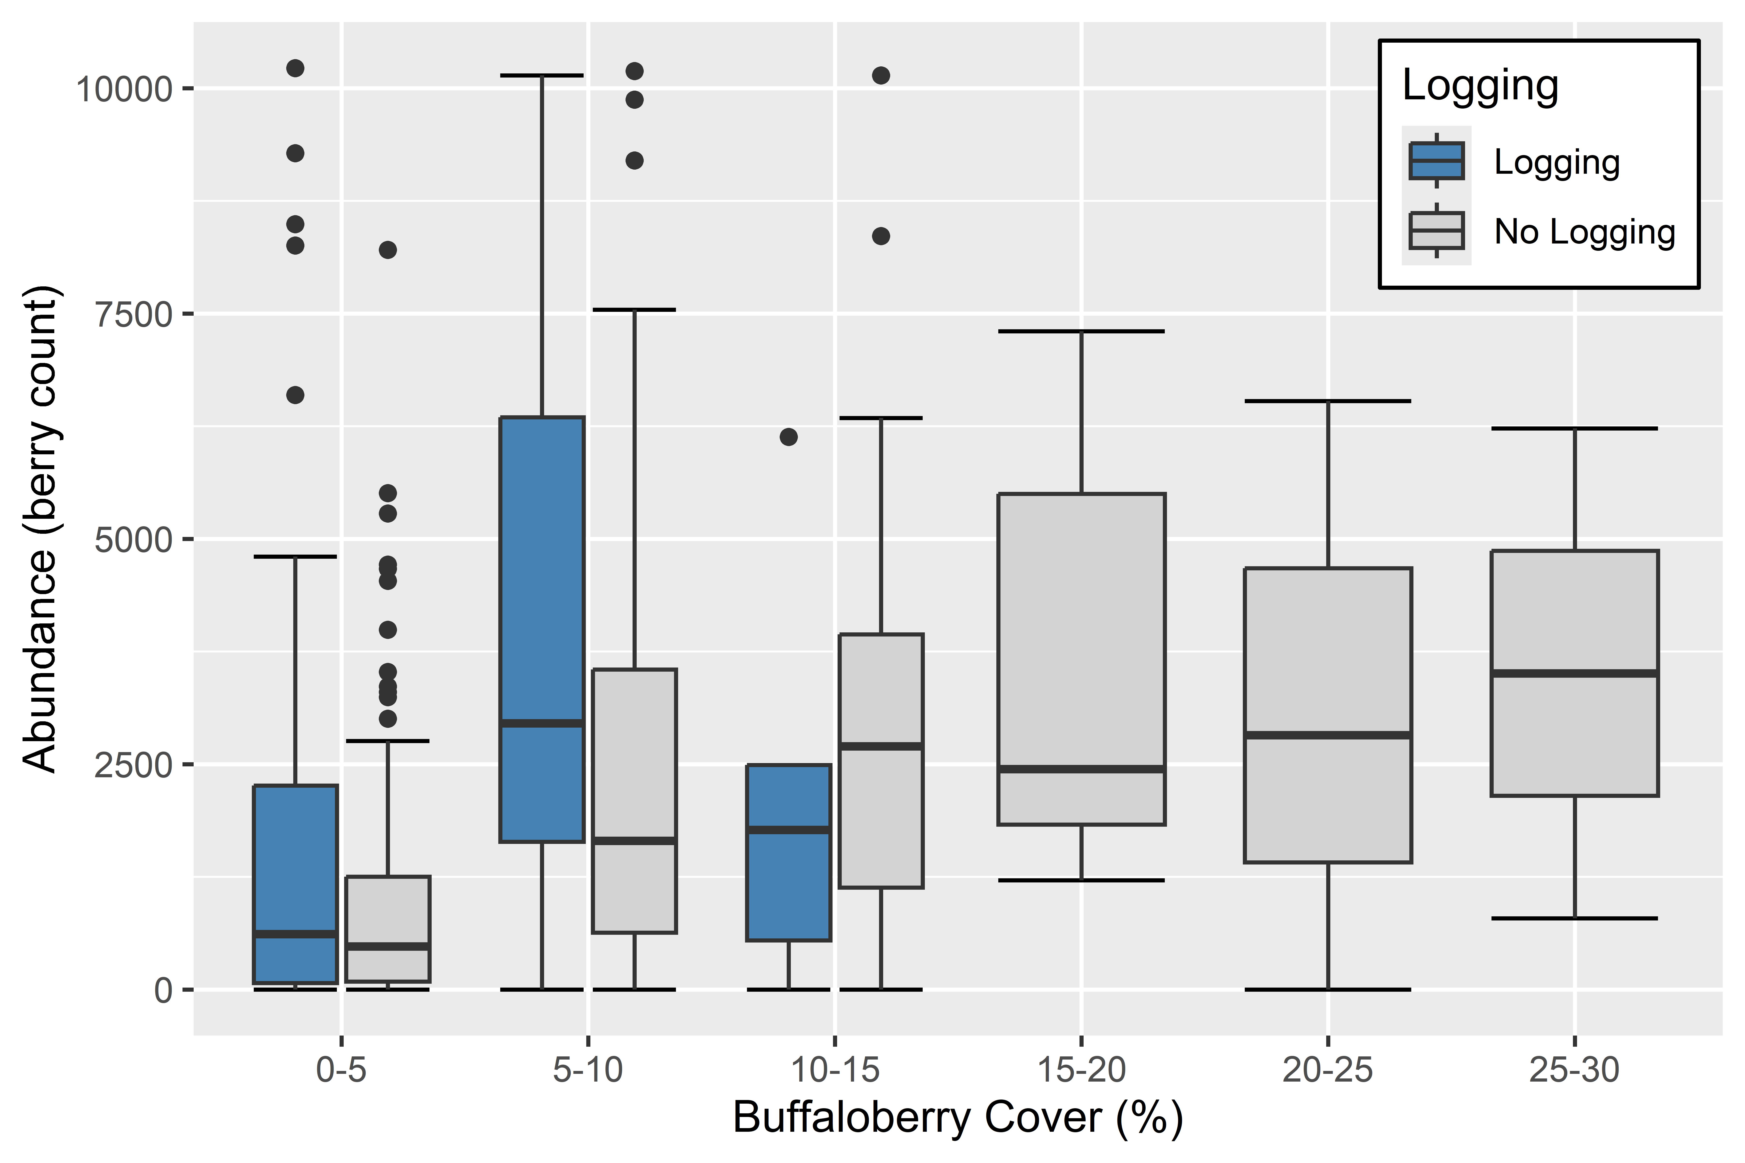

3B.

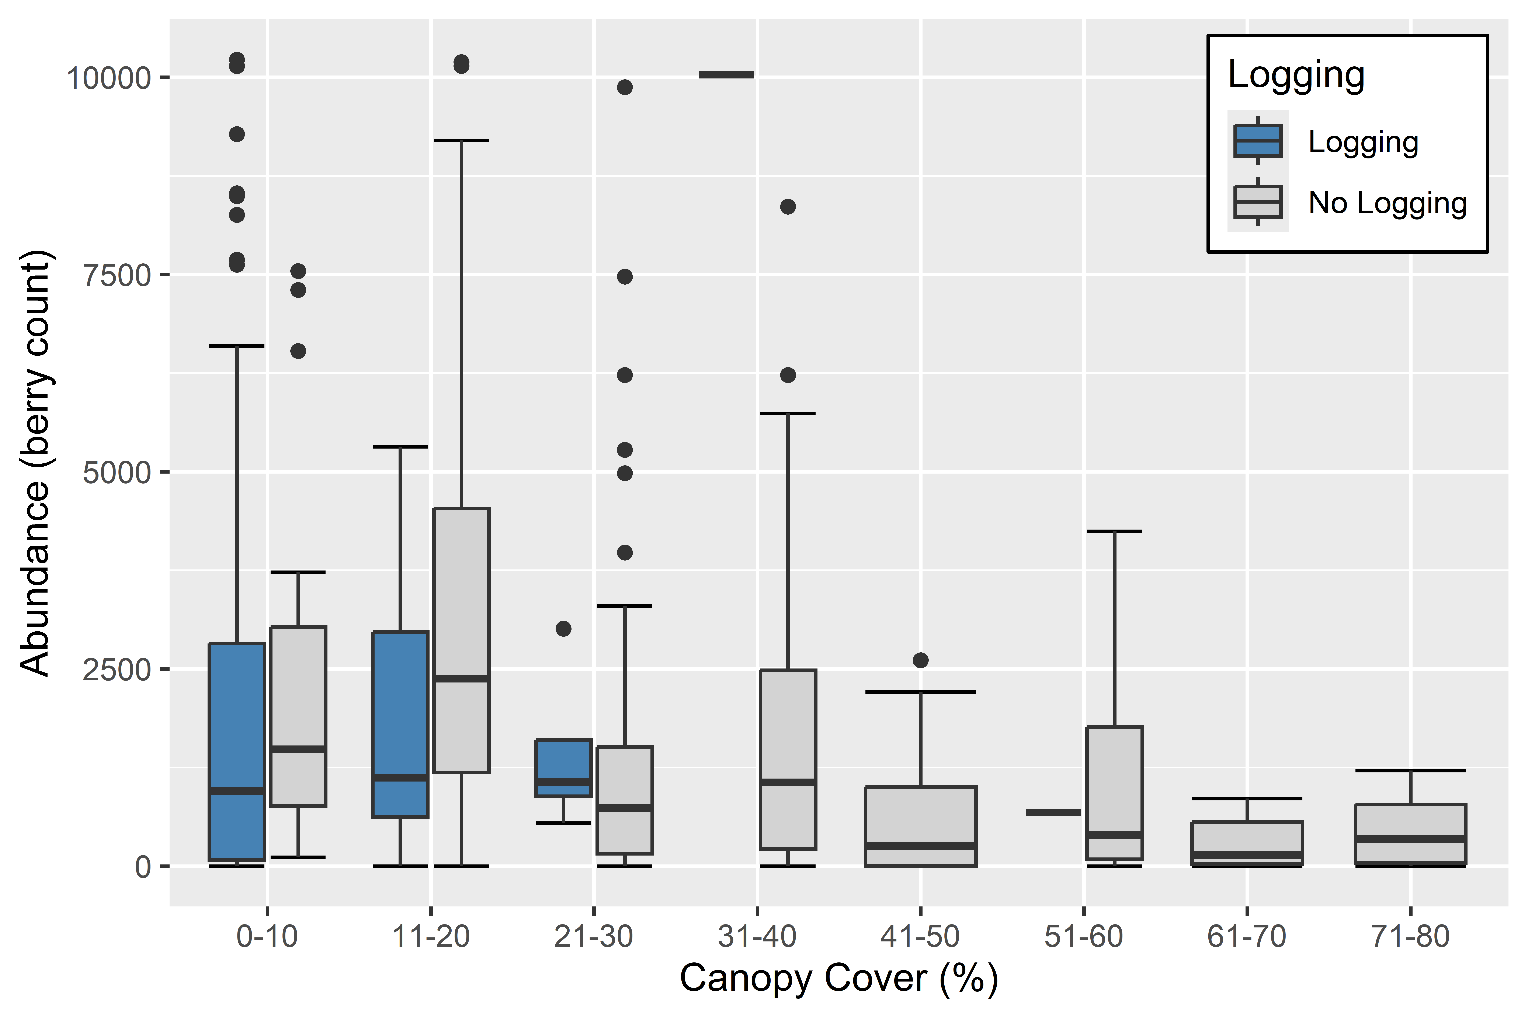

Figure 4. Buffaloberry cover vs canopy cover in all sites (*n*=353).

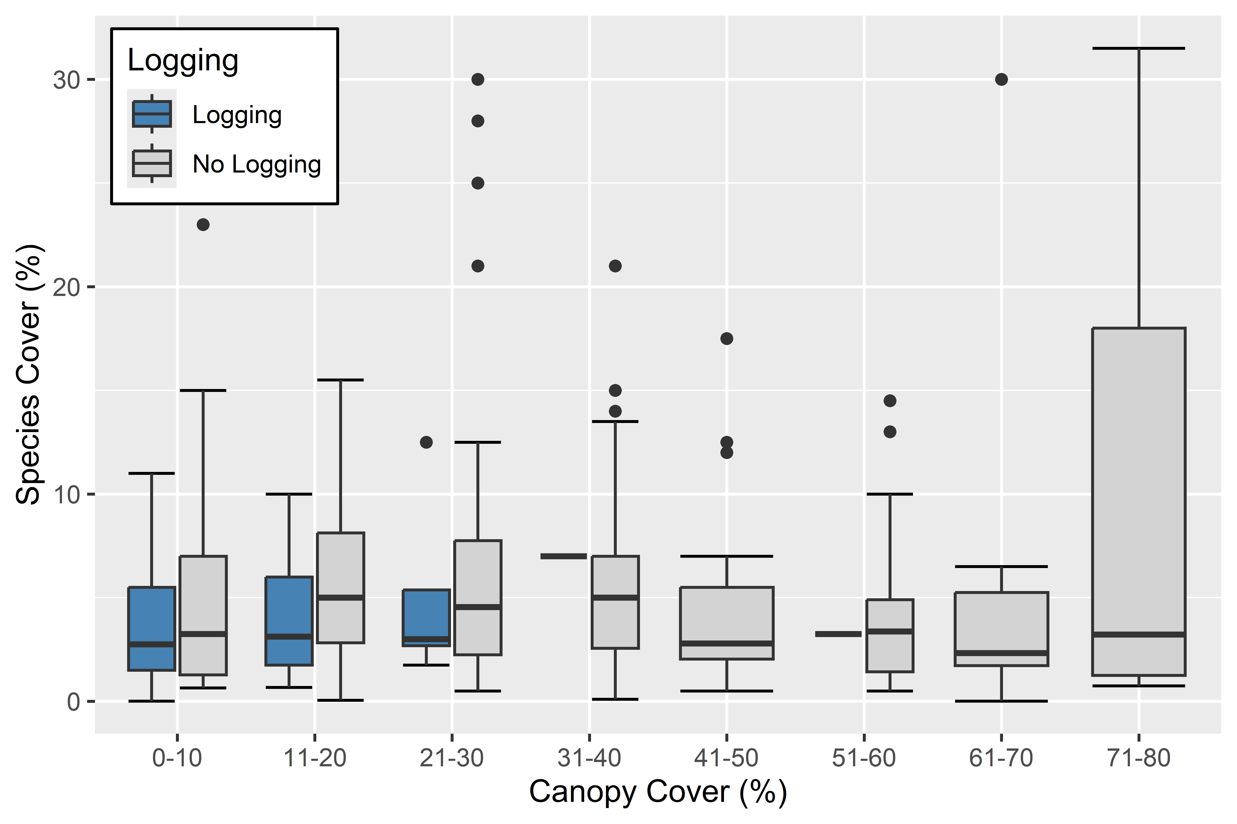

Figure 5. Buffaloberry plant species cover by BEC zone (*n*=339).



Figure 6. Buffaloberry berry abundance by BEC zone (*n*=322).[8]



Figure 7. Canopy cover by BEC zone (*n*=339).



8. TABLES AND APPENDICES

Table 1. Buffaloberry cover and berry abundance by BEC zone (A) and subzone variant (B).

1A.



1B.



Table 2. Mean canopy cover, buffaloberry cover and berry abundance in all, logged and unlogged forest sites by BEC zone (A) and subzone variant (B).

2A.



2B.



Table 3. Correlation (r) between buffaloberry cover and berry abundance and site history and site properties in all, logged and not logged site by BEC zone.



Appendix 1.1. Buffaloberry berry abundance vs buffaloberry cover in selected biogeoclimatic zones (i.e. BWBS, ESSF, ICH, IDF, MS, SBS).

|  |  |  |
| --- | --- | --- |
| 1.1A. BWBS | 1.1B. ESSF | 1.1C. ICH |
|  |  |  |
| 1.1D. IDF | 1.1E. MS | 1.1F. SBS |
|  |  |  |

Appendix 1.2. Buffaloberry cover vs canopy cover in selected biogeoclimatic zones (i.e. BWBS, ESSF, ICH, IDF, MS, SBS).

|  |  |  |
| --- | --- | --- |
| 1.2A. BWBS | 1.2B. ESSF | 1.2C. ICH |
|  |  |  |
|  |  |  |
| 1.2D. IDF | 1.2E. MS | 1.2F. SBS |
|  |  |  |

Appendix 1.3. Buffaloberry berry abundance vs canopy cover in selected biogeoclimatic zones (i.e BWBS, ESSF, ICH, IDF, MS, SBS).

|  |  |  |
| --- | --- | --- |
| 1.3A. BWBS | 1.3B. ESSF | 1.3C. ICH |
|  |  |  |
|  |  |  |
| 1.3D. IDF | 1.3E. MS | 1.3F. SBS |
|  |  |  |

Appendix 2. Buffaloberry plant cover (2.1) and berry abundance (2.2) and tree canopy cover (2.3) in logged and unlogged sites by variant.

2.1. Buffaloberry cover

Appendix 2. Buffaloberry plant cover (2.1) and berry abundance (2.2) and tree canopy cover (2.3) in logged and unlogged sites by variant.

2.2 Buffaloberry berry abundance

Appendix 2. Buffaloberry plant cover (2.1) and berry abundance (2.2) and tree canopy cover (2.3) in logged and unlogged sites by variant.

2.3. Canopy cover

Appendix 3.1. Rpart tree for buffaloberry cover by biogeoclimatic zone (BWBS, ESSF, ICH, IDF, MS, SBS).

|  |  |  |
| --- | --- | --- |
| 3.1A. BWBS | 3.1B. ESSF | 3.1C. ICH |
|  |  |  |
| 3.1D. IDF | 3.1E. MS | 3.1F. SBS |
|  |  |  |

Appendix 3.2. Rpart tree for buffaloberry berry abundance by biogeoclimatic zone (BWBS, ESSF, ICH, IDF, MS, SBS).

|  |  |  |
| --- | --- | --- |
| 3.2A. BWBS | 3.2B. ESSF | 3.2C. ICH |
|  |  |  |
| 3.2D. IDF | 3.2E. MS | 3.2F. SBS |
|  |  |  |

1. Site data included BEC unit, canopy cover, % slope, aspect (azimuth), elevation, and whether the site had been logged or not. Azimuth values were converted to “folded aspect” such that the sites that receive comparable solar radiation hence heatload have comparable aspect values (See [McCune, 2007](https://sites.science.oregonstate.edu/~mccuneb/JVSreprint13.603-606.pdf)).
2. *Shepherdia canadensis* North American distribution map from [Virginia Tech Dendrology Fact Sheet](https://dendro.cnre.vt.edu/dendrology/syllabus/factsheet.cfm?ID=692).
3. Site data included BEC unit, canopy cover, % slope, aspect (azimuth), elevation, latitude and longitude.
4. Aspect azimuth values were converted to “folded aspect” so that the site that receive comparable solar radiation – i.e. SSE- and SSW-facing have the same value (See McCune 2007).
5. number of sites sampled in the subzone or subzone variant.
6. With the calculation of “folded aspect” aspects that receive comparable solar radiation; SSE and SSW have the same value (See McCune 2007).
7. Berry abundance outliers (greatest 5%) removed.
8. Berry abundance outliers (greatest 5%) removed.